Table of Content

|  |  |  |
| --- | --- | --- |
| S.NO. | CONTENT | PAGE NO. |
| 1. | Title of the BCA Project |  |
| 2. | Introduction and Objectives of the Project |  |
| 3. | Project Category |  |
| 4. | Analysis |  |
| 5. | A complete structure |  |
| 6. | Tools / Platform, Hardware and Software Requirement specifications |  |
| 7. | Are you doing this project for any Industry/Client? |  |
| 8. | Future scope and further enhancement of the project. |  |

1. Title of Project

E-Learning Management System

2. Introduction and Objectives of the Project

3. Project Category

4. Analysis

5. A complete structure

5.3 PROCESS LOGIC FOR EACH MODULE

PROJECT CONTROL SYSTEMS

The purpose of controlling a project is to monitor the progress of the activities against the plans, to ensure that the goals are being approached and eventually achieved. Other aspects of control are to detect, as soon as possible, when deviations from the plan are occurring so that corrective action may be taken. Most project control techniques are based on breaking down the goal of the project into several Intermediate goals. Each Intermediate goal can turn be broken further. This process can be repeated until each goal can turn be broken further. This process can be repeated until each goal is small enough to be understood. We can plan for each goal individually – its resource requirements, assignments of responsibility, scheduling, etc.

Two general scheduling techniques are GANTT charts and PERT Charts as discussed below.

GANTT CHART:

A bar chart is perhaps the simplest form of formal project management. The bar chart also known as GANTT CHART is used almost exclusively for scheduling purpose and therefore controls only the time dimension of projects. Gantt chart is a project control technique that can be used for several purposes, including scheduling, budgeting and resource planning. A Gantt chart is a bar chart, with each bar representing an activity. The bars are drawn against a time line. The length of each bar is proportional to the length of time planned for the activity. Gantt chart can take different forms depending on their Intended use. They are best for resource scheduling. Gantt charts are useful for resource planning and scheduling. Gantt chart they show the tasks and their duration clearly. However they do not show Inter task dependencies plainly.

PERT CHART:

Unlike the bar chart, PERT can be both cost and a time management system PERT is organized by events and activities or tasks. PERT has several advantages over bar charts and is likely to be used with more complex projects. One advantage of PERT is that it is a scheduling device that also shows graphically which tasks must be completed before others are begun. PERT enable the calculation of a Critical path. Each path and cost associated with each task along a path is calculated, and the path that requires the greatest amount of elapsed time is the Critical path. Calculation of the critical path enables project manager to monitor this series of tasks more closely. PERT controls time and cost during the project the project and also facilities finding the right balance between completing a project on time and completing it within budget. PERT recognizes that projects are complex that some task must be completed before other can be started and that the appropriate way to manage a project is to be defined and control each task. Because projects often fall behind schedule, PERT is designed to facilitate getting back schedule. PERT is based in part on the premise that subjective estimates of the total completion time for a project are usually greatly inferior to the sum of subjective estimates for each task. The PERT chart gives a graphical representation of this information.

Advantages of PERT

➢ It forces the manager to plan.

➢ It shows an Interrelationship among the tasks in the project, in particular, clearly identifies the critical path of the project, thus helping to focus on it.

➢ It exposes all possible parallelism in the activities and thus helps in allocating resources.

➢ It allows scheduling and simulation of alternative schedule.

➢ It enables the manager to monitor and control the project.

Despite these advantages, PERT is just a tool, and its use does not automatically guarantee the success of the project. Gantt chart can be derived automatically from PERT charts.

The charts are shown in figure A (Gantt chart) and B (PERT Chart).

GANTT CHART

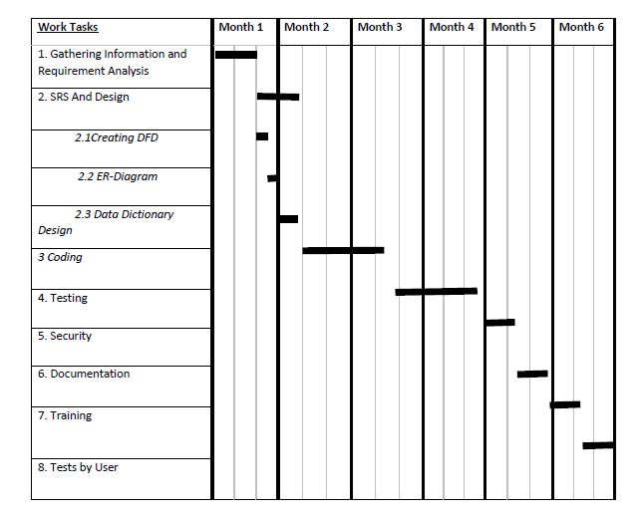

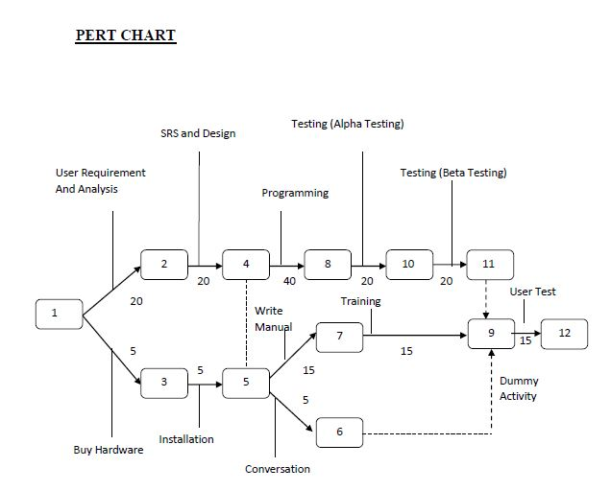

SOFTWAR ENGINEERING APPROACH:

The field of software engineering is related to the development software in systematic manner unlike simple programs which can be developed in isolation and there may not be any systematic approach being followed. As there is large difference between programming and software engineering. As it provides models that lead to the production of well documented software in a manner that is predictable. For a mature process, it should be possible to determine in advance how much time and effort will be required to produce the final product. To develop successful software, I have to follow some models, which act as guidelines.

The model I have used is Waterfall Model or Classic Life Cycle. In this model first of all the existed system is observed. Then customer requirements are taken in consideration then planning, modelling, construction and finally deployment.

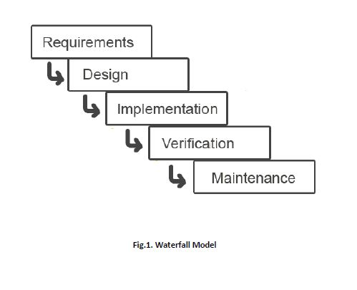

SYSTEM DESIGN:

INTRODUCTION:

System design is the specification of a detailed computer-based solution. (Bentley, L, D., & Whitten, J, L (2008)) Also known as physical design.

There were many techniques or approaches that are concerning to the aspect of the machine design and can be categorized as follow:

Model-Driven Approaches

Rapid Application Development (RAD)

Joint Application Development (JAD)

5.4 TESTING AND DEBUGGING:

Testing is the process of executing the program with the intent of finding errors and it establishes confidence that the program does what it is supposed to do. It can be done in many ways:

*Unit Testing:* It is testing of individual module. Before initiating unit testing, it must be ensured that the code is peer previewed.

*Integration Testing:* It is performed after all the software units are combined together. The objective here is to test the software interfaces. Project team conducts the integration testing. Before entering integration testing, it may be ensured that code review and unit testing have been performed on the individual software modules.

System Testing: The software is compiled as product and then it is tested as a whole. This can be accomplished using one or more of the following tests:

• Functionality testing - Tests all functionalities of the software against the requirement.

• Performance testing - This test proves how efficient the software is. It tests the effectiveness and average time taken by the software to do desired task. Performance testing is done by means of load testing and stress testing where the software is put under high user and data load under various environment conditions.

• Security & Portability - These tests are done when the software is meant to work on various platforms and accessed by number of persons.

Regression Testing: Whenever a software product is updated with new code, feature or functionality, it is tested thoroughly to detect if there is any negative impact of the added code. This is known as regression testing.

5.5 REPORT GENERATION:

Any project or program is required what input it is giving. It is the input, which matters the most and any managements, which is decided for computerization of pay bills for their organization. Spending some money on it does the project designing of the organization. So a cost analysis is also involved to see what benefits the organization can get out of the project.

The Input of the project “ONLINE BANKING SYSTEM” has a Main Form containing the list of Different Forms i.e. admin/developer form, manager form, employee form, login form, new user form, personal information form, reporting form, review form, transaction form and many other forms. The Project also includes the salary description of the employees given to their details and the balance description, transaction report(s) of individual customer. The Current system has been made so versatile that any Organization can implement it.

Any project or program is required on what output it is giving. Output is compulsory for any organization for management to take the decision for computerization of their organization. Spending money on it, the organization needs in what respect the project can be benefited, which is possible by viewing the output. So a cost analysis is also involved to see what benefits the organization to give the output of the project.

The System has the facility to view different reports. It also contains the pages, which display the list of employees working in the Organization, their performances etc. which is the output of the project.

Any project or program is required on what output it is giving. Output is compulsory for any organization for management to take the decision for computerization of their organization. Spending money on it, the organization needs in what respect the project can be benefited, which is possible by viewing the output. So a cost analysis is also involved to see what benefits the organization to give the output of the project.

The System has the facility to view different reports. It also contains the pages, which display the list of employees working in the Organization, their performances etc. which is the output of the project.

6. TOOLS, SOFTWARE & HARDWARE REQUIREMENTS

We have a wide range of options of languages. From these options we can choose appropriate platform/ tools and languages for development of the project. Some of these are as follows :-

Project Category: Web-Based Application

SOFTWARE REQUIREMENTS:

IDE: NetBeans 8.0(or 11.2)

Front End: HTML, CSS, JavaScript, AJAX, Bootstrap

Programming Language: JAVA

Back End: JSP, Servlet, Hibernate

RDBMS: MySQL 8.10

Server: Apache Tomcat 8.0

Browser: Chrome, Firefox etc.(latest version)

Operating System: Windows 7 and above

HARDWARE REQUIREMENTS:

Processor : Intel Pentium, Core duo or more

Ram : 2GB or more

Cache : 512 KB

Hard-disk : 50 GB hard disk recommended

Monitor, Keyboard & mouse.

7. Are you doing this project for any Industry/Client? Mention Yes/No.

NO.

8. FUTURE SCOPE AND ENHANCEMENT OF PROJECT

BIBLIOGRAPHY

Websites

• http://www.google.com

• http://www.codeproject.com

• http://www.w3schools.com

• http://www.sqltuner.com

• https://getbootstrap.com/

• https://www.javatpoint.com/

Books

• Head First (JAVA)

• HTML & CSS: Design and Build Web Sites

• Head First SQL: Your Brain on SQ

• SQL Bible, 2nd Edition (Paperback)